• Create a player class with the following data members

Name of the player, the game the Player play, gender, age and the rank of the player.

Defines the constructor (default and normal)

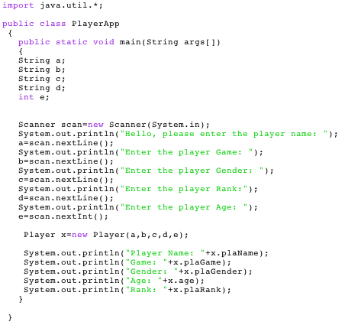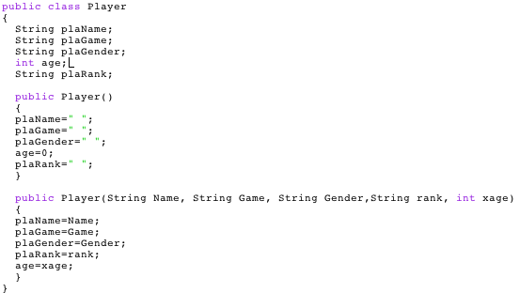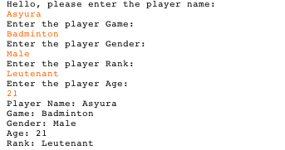

• Create an Employee class with the following data members and methods:

Name of the Employee, the designation and the id number of the Employee

Constructors – default and normal

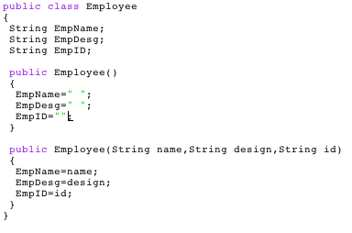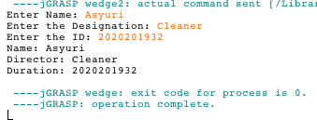

• Create a Movie class with the following data members:

Attributes: Movie name, movie director, duration of play time, ticket price

Methods: constructors (default and normal)

